N-Queens Problem

Problem
- N - Queens problem is to place n - queens in such a manner on an n x n chessboard that no queens attack each other by being in the same row, column or diagonal.
- For n =1, the problem has a trivial solution, and no solution exists for n =2 and n =3.
N=2
Q1 & Q2 to be placed in a 2x2 chessboard
 | Q1
Q2 X | Q2 x
No Solution
N=3
Place 3 queens in 3 X 3 chessboard
 |  | Q1
Q2 | Q2 X | Q2 X
Q3 X | Q3 X | Q3 X
No Solution
- So first we will consider the 4-queens problem and then generate it to n - queens problem.
- Given a 4 x 4 chessboard and number the rows and column of the chessboard 1 through 4.
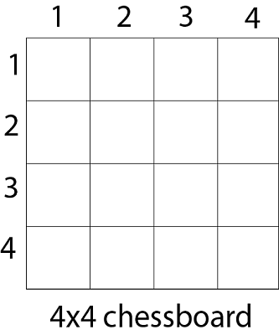
- Since, we have to place 4 queens such as q1 q2 q3 and q4 on the chessboard, such that no two queens attack each other.
- Each queen must be placed on a different row, i.e., we put queen "i" on row "i."
Solution
- We place queen q1 in the very first acceptable position (1, 1).
- Next, we put queen q2 so that both these queens do not attack each other.
- We find that if we place q2 in column 1 and 2, then the dead end is encountered.
- Thus the first acceptable position for q2 in column 3, i.e. (2, 3) but then no position is left for placing queen 'q3' safely.
Q1
Q2
Q3
Q4

- So we backtrack one step and place the queen 'q2' in (2, 4), the next best possible solution.
- Then we obtain the position for placing 'q3' which is (3, 2).
- But later this position also leads to a dead end, and no place is found where 'q4' can be placed safely.
- Then we have to backtrack till 'q1' and place it to (1, 2) and then all other queens are placed safely by moving q2 to (2, 4), q3 to (3, 1) and q4 to (4, 3).
- That is, we get the solution (2, 4, 1, 3). This is one possible solution for the 4-queens problem.
- For another possible solution, the whole method is repeated for all partial solutions.
- The other solutions for 4 - queens problems is (3, 1, 4, 2) i.e.

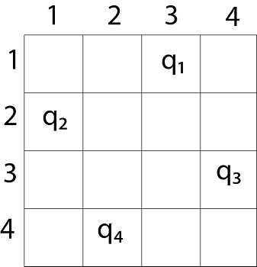

- The implicit tree for 4 - queen problem for a solution (2, 4, 1, 3) is as follows: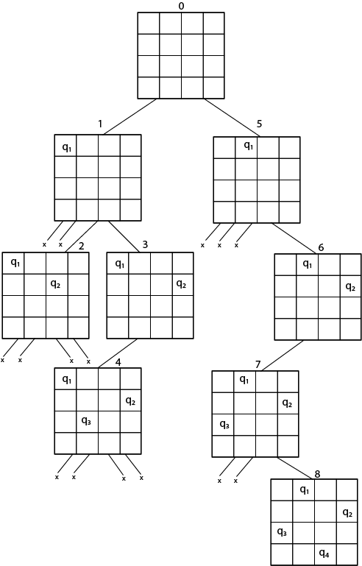
4-tuple=(2,4,1,3)
X1=2 -Queen 1 is placed in the 2nd column
X2=4 Queen 2 is placed in the 4th column
X3=1 Queen 3 is placed in the 1st column
X4=3 Queen 4 is placed in the 3rd column
- It can be seen that all the solutions to the 4 queens problem can be represented as 4 - tuples (x₁, x₂, x₃, x₄) where x_{i} represents the column on which queen "q_{i}" is placed.
- If two queens are placed at position (i, j) and (k, l).
- Then they are on same diagonal only if (i - j) = k - l or i + j = k + l.
- The first equation implies that j - l = i - k.
- The second equation implies that j - l = k - i.
- Therefore, two queens lie on the duplicate diagonal if and only if |j-l|=|i-k|

ALGORITHM
- Place (k, i) returns a Boolean value that is true if the k^{th} queen can be placed in column i.
- It tests both whether i is distinct from all previous costs x₁, x₂,....x_{k-1} and whether there is no other queen on the same diagonal.
- Using place, we give a precise solution to the n- queens problem.
- Place (k, i)
- {
- For j ← 1 to k - 1
- do if (x [j] = i)
- or (Abs x [j]) - i) = (Abs (j - k))
- then return false;
- return true;
- }
- Place (k, i) return true if a queen can be placed in the k^{th} row and i^{th} column otherwise return is false.
- x [] is a global array whose final k - 1 values have been set.
- Abs (r) returns the absolute value of r.
- N - Queens (k, n)
- {
- For i ← 1 to n
- do if Place (k, i) then
- {
- x [k] ← i;
- if (k ==n) then
- write (x [1....n));
- else
- N - Queens (k + 1, n);
- }
- }

K=1,i=1
N-queens(1,4)
Place(1,1)

Q1
Q2
N-queens (2,4)
K=2, n=4
i=1 to 4
Place (2, 1)
j=1
X[1]=1
I=2
Place(2,2)
X[j]=1
Abs(x[j]-i)=abs(j-k)
Abs(1-2)=abs(1-2)
1=1

